# 繪製房屋大小與價格的散布圖。

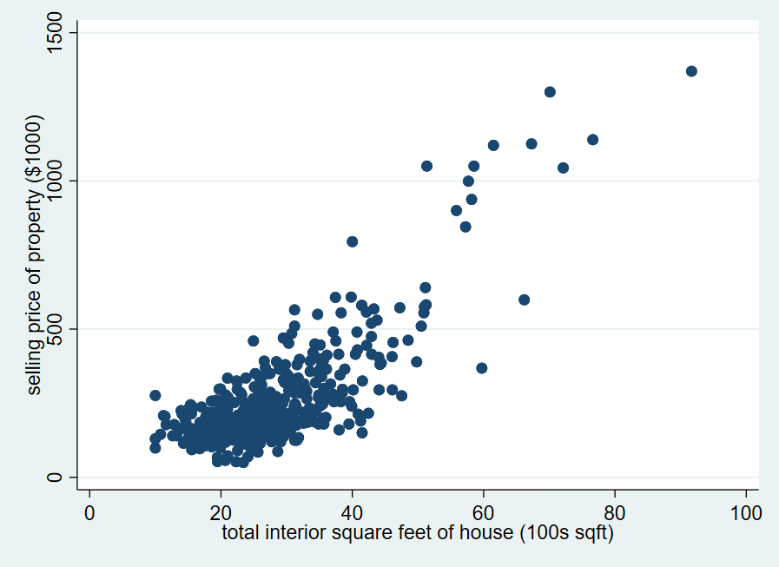

# 估計線性歸模型 $PRICE=β_{1}+β_{2}SQFT+ϵ$

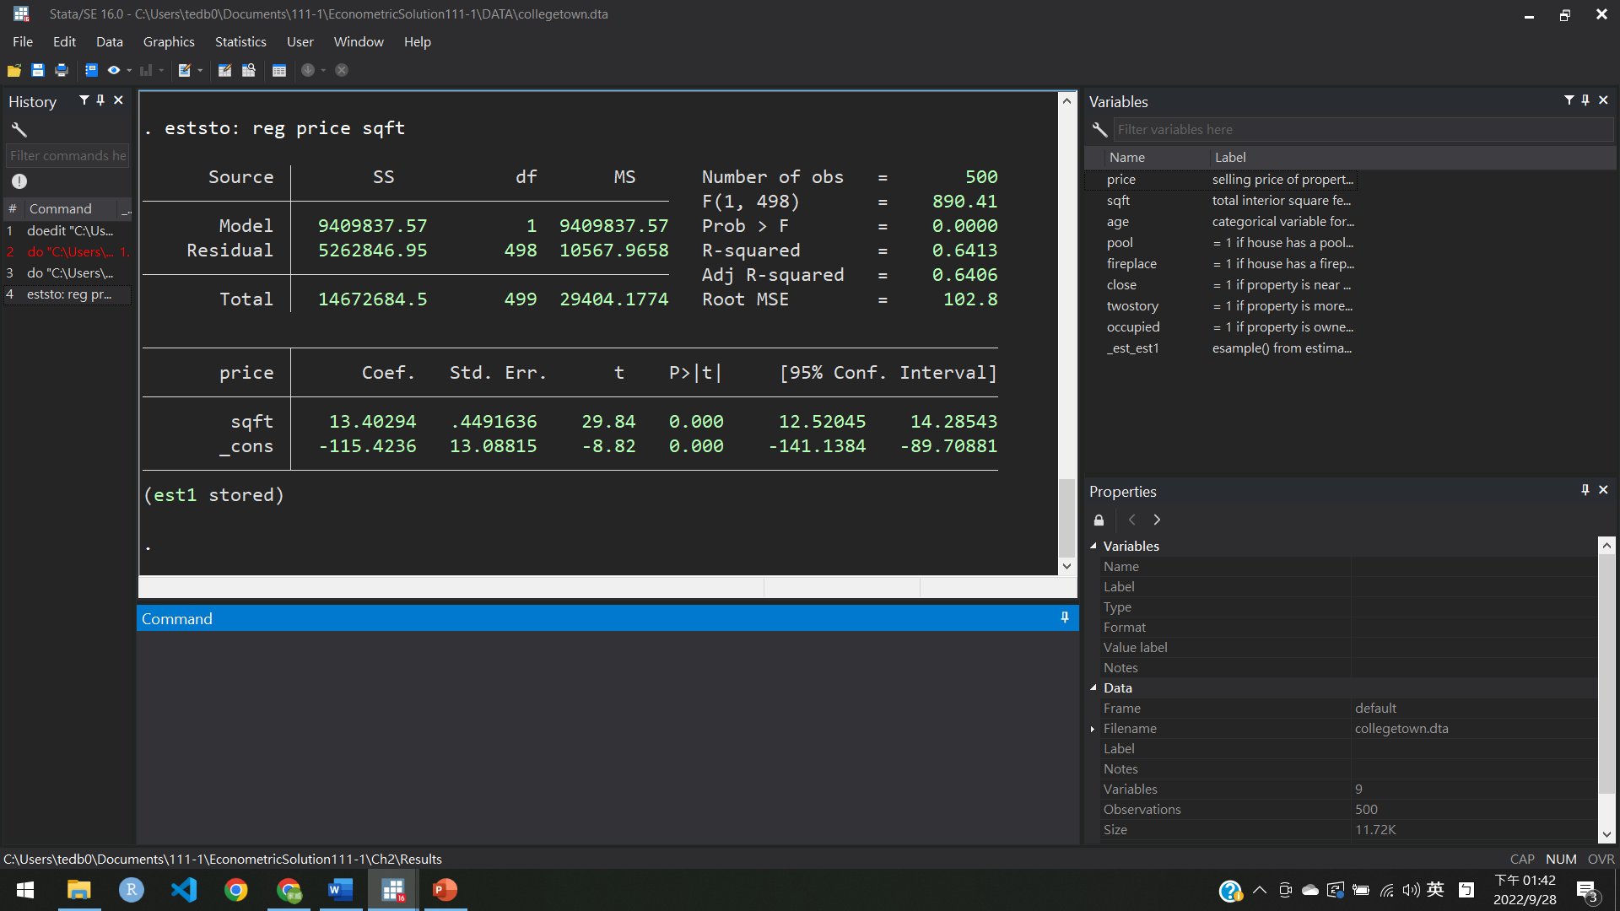

|  |  |
| --- | --- |
| $$β_{1}$$ | -115.4 |
| $$β_{2}$$ | 12.3 |

畫出結果

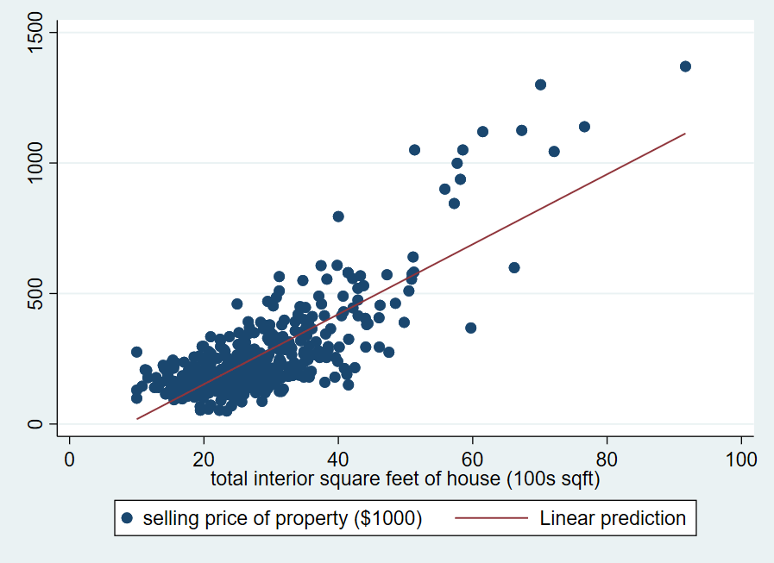

斜率 > 0，表示隨著面積越大，房價就越貴

# 估計二次歸模型 $PRICE=β_{1}+β_{2}SQFT^{2}+ϵ$

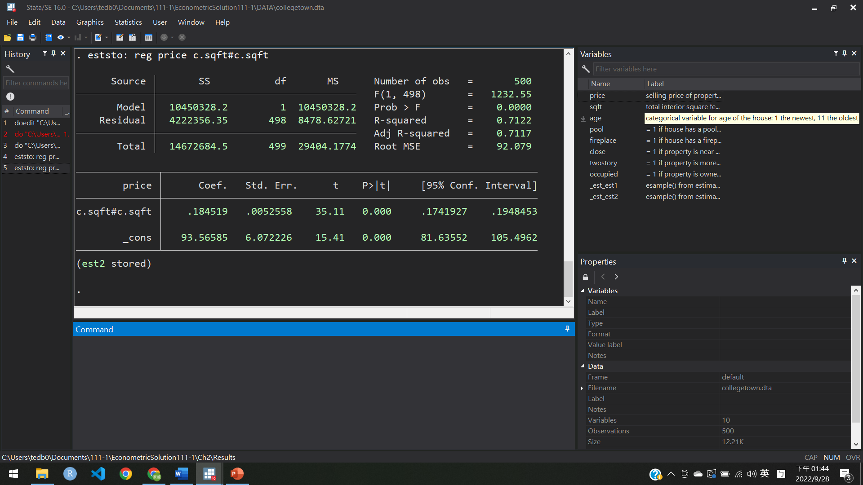

|  |  |
| --- | --- |
| $$β_{1}$$ | 0.184 |
| $$β_{2}$$ | 93.56 |

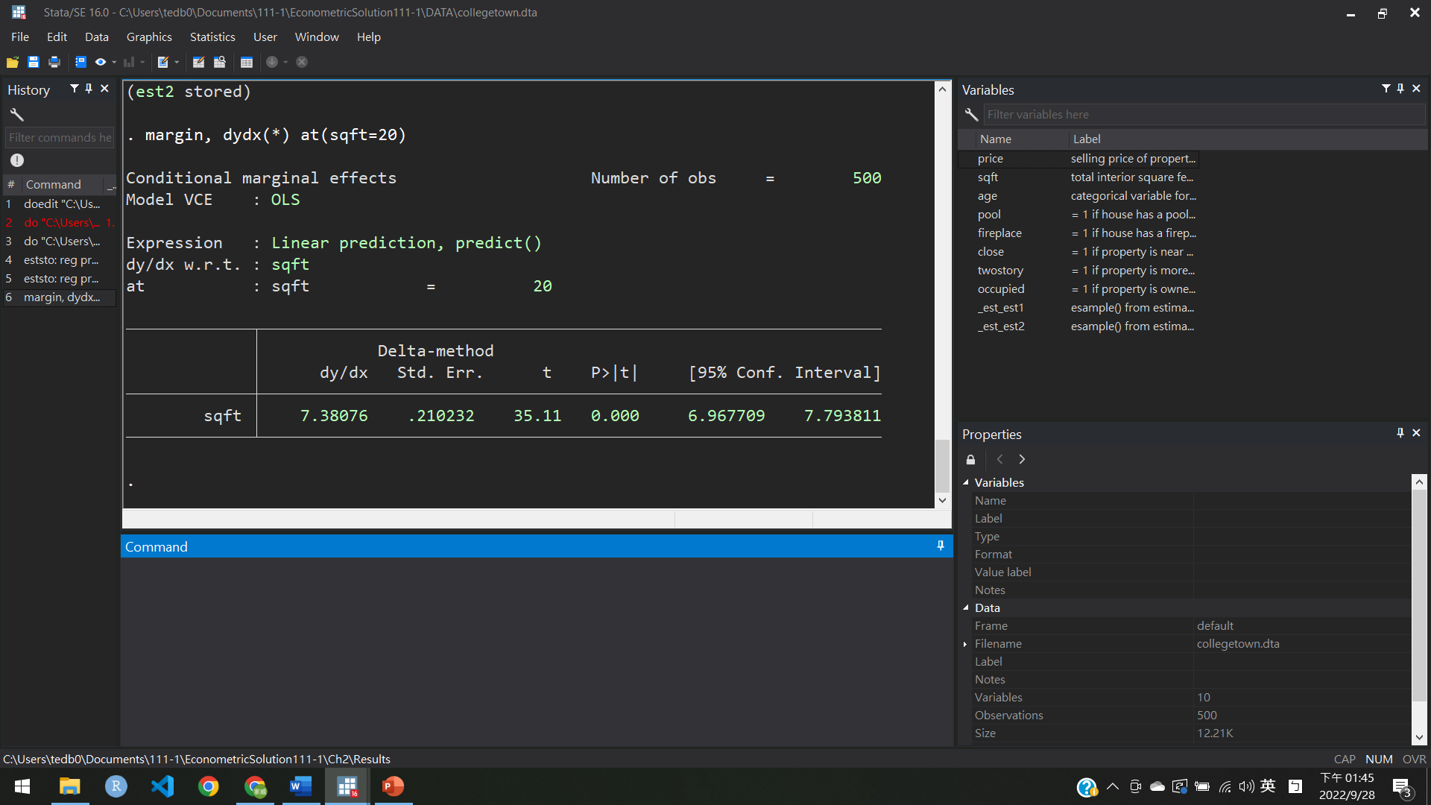

兩回歸比較

|  |  |  |
| --- | --- | --- |
|  | (1) | (2) |
|  | price | price |
| sqft | 13.40*** |  |
|  | (29.84) |  |
|  |  |  |
| c.sqft#c.sqft |  | 0.185*** |
|  |  | (35.11) |
|  |  |  |
| _cons | -115.4*** | 93.57*** |
|  | (-8.82) | (15.41) |
| *N* | 500 | 500 |

*t* statistics in parentheses

* *p* < 0.05, ** *p* < 0.01, *** *p* < 0.001